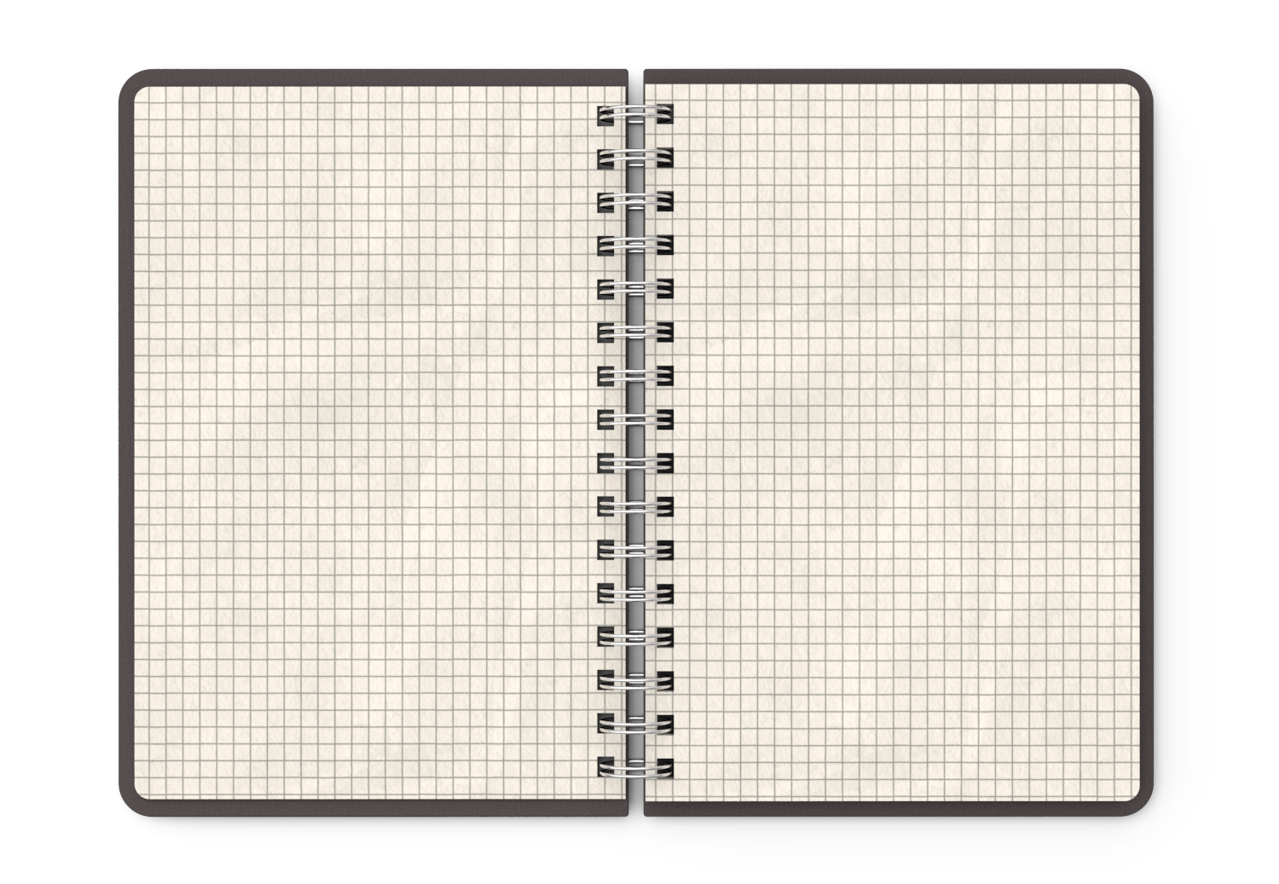

5. Record any new vocabulary words that you learned in today’s lesson.

4. Write your notes using a graphic organizer or an outline.

10. Stape or glue any homework, classwork, or worksheet from this section horizontally and fold it.

7. At the end of class, you will do an activity or be assigned a question to answer. Complete the exit ticket before the end of class.

**Questions ?**

6. As you go through the lesson, record any questions that you have. When you ask them in class, write the answer.

**Exit Ticket:**

2. Section number and title of the section that we will take notes on

8. After completing the Exit Exercise, read the learning goal. On a scale from 1 to 5, how well do you understand today’s topic?

**Notes:**

**New**

**Vocabulary**

1. Today’s

date

3. Record the learning goal that is posted on the whiteboard.

9. I will stamp your daily work:

learning goal, questions, notes, vocabulary

exit exercise,

check yourself

**Stamp**

**Check**

**Yourself**

**Learning Goal:**

**Lesson Title**

**Date**